* Dotnet new => gives all the available Templates for Dotnet
* Code – r {ProjectName} – Opens project in VS Code
* Binding Sources => FromUI, FromBODY, From ROUTE, FROMQUERY, FROMHEADER
* **Entity Framewrok add** -

dotnet add package Microsoft.EntityFrameworkCore

dotnet add package Microsoft.EntityFrameworkCore.Design

dotnet add package Microsoft.EntityFrameworkCore.SqlServer

* **dotnet tool {install/Update} --global dotnet-ef**
* **dotnet ef migrations add <MigrationName>**

Up and Down methods (

Table will be created from DataSet property in DBContext

)

**If Want to remove -**

dotnet ef migrations remove

* **dotnet ef database update**
* **dotnet add package AutoMapper.Extensions.Microsoft.DependencyInjection**
* **dotnet add package Microsoft.AspNetCore.JsonPatch**
* **dotnet add package Microsoft.AspNetCore.Mvc.NewtonsoftJson**

**(**

services.AddControllers().AddNewtonsoftJson(s => {

            s.SerializerSettings.ContractResolver = new CamelCasePropertyNamesContractResolver();

            });

**)**

**Patch Body -**

[

{

       "op":"replace",

       "path":"/howto",

       "value":"Some New Value"

}

]

* dotnet add package Swashbuckle.AspNetCore

app.UseSwagger();

            app.UseSwaggerUI(c =>

            {

                c.SwaggerEndpoint("/swagger/v1/swagger.json", "My API V1");

            });

services.AddSwaggerGen();

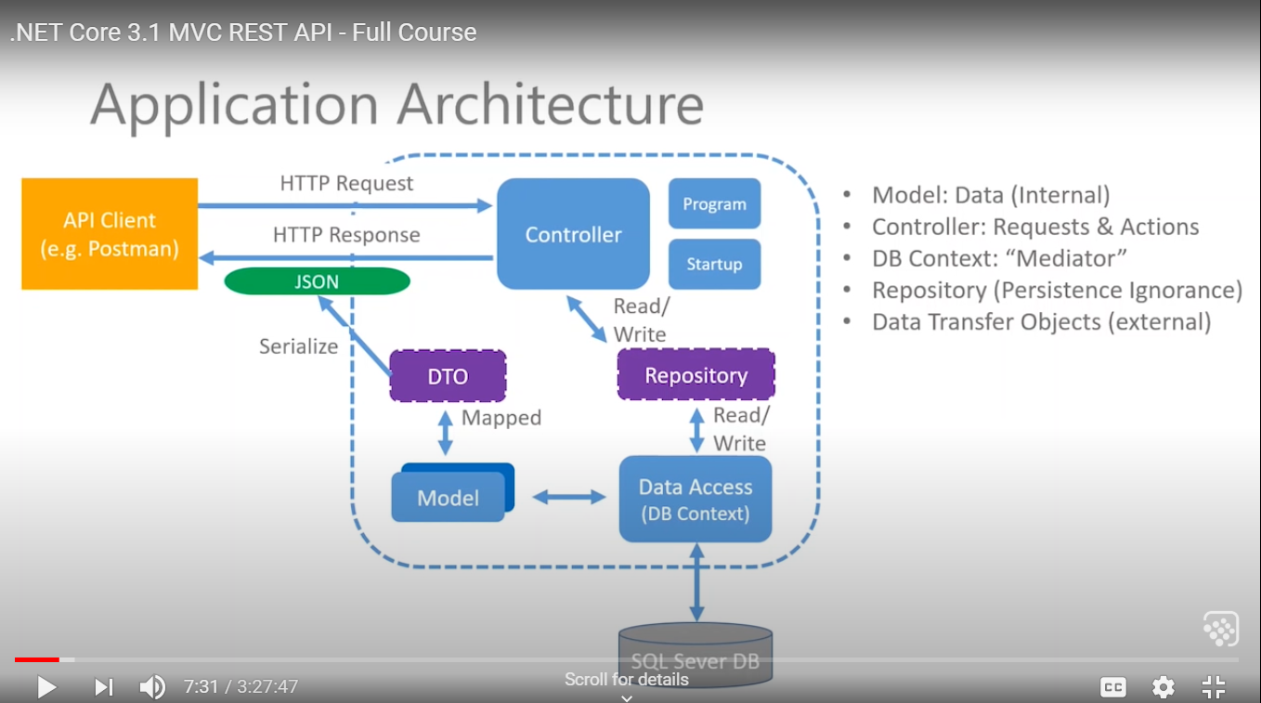

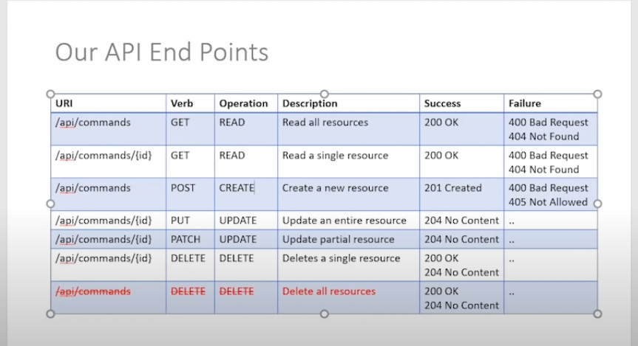

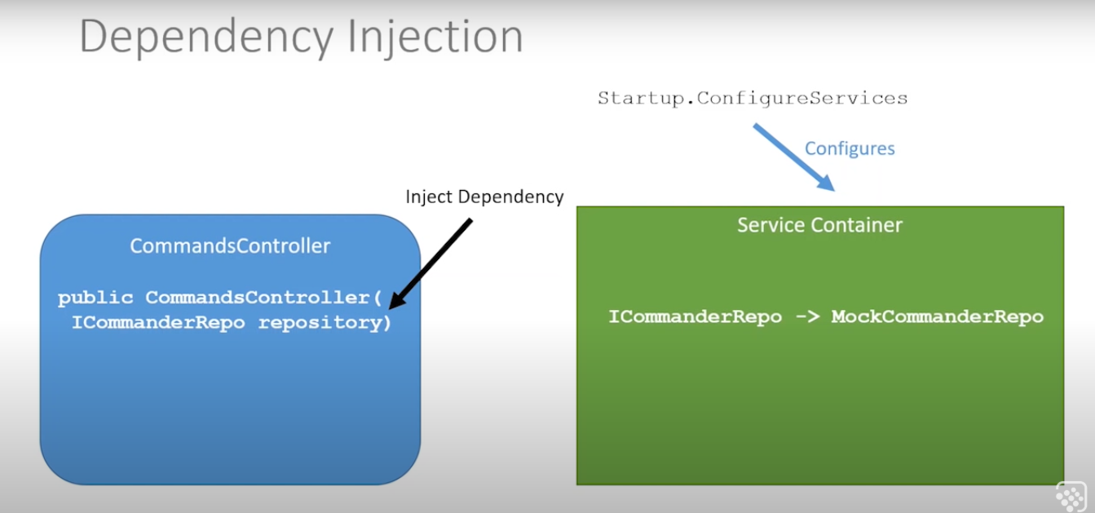

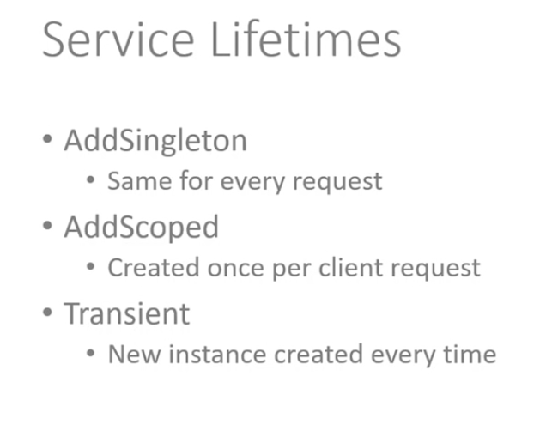

**Why DTO (Data transfer Object) –**

